COMMUNITY EMPOWERMENT (SCOTLAND) ACT 2015
FALKIRK COUNCIL ASSET TRANSFER REQUEST FORM
IMPORTANT NOTES:
This is an application form which can be used to make an Asset Transfer request to Falkirk Council.
Any Community Body interested in making an Asset Transfer Request is advised to contact the Asset Team on strategicpropertyreview@falkirk.gov.uk before making the request so that we can discuss your proposal.
Please complete the asset transfer request form if the property/land is owned/leased/managed by Falkirk Council.
It is essential that you read the Asset Transfer guidance provided by the Scottish Government before making a request.
When completed, this form should be emailed to strategicpropertyreview@falkirk.gov.uk or sent to
The Asset Team
Falkirk Council
4 Stadium Way
Falkirk
FK2 9EE

Section 1: Information about the Community Transfer Body (CTB) making the request
  - Name of the CTB making the asset transfer request
Bloomin’ Bo’ness
  - CTB address. This should be the registered address, if you have one.
Postal address: [REDACTED]
Postcode: [REDACTED]

  - Contact details. Please provide the name and contact address to which correspondence in relation to this asset transfer request should be sent.
Contact name: [REDACTED]
Postal address: [REDACTED]
Postcode: [REDACTED]
Email: bloominboness@outlook.com
Telephone: [REDACTED]
☐ We agree that correspondence in relation to this asset transfer request may be sent by email to the email address given above. (Please tick to indicate agreement)
You can ask Falkirk Council to stop sending correspondence by email, or change the email address, by telling them at any time, as long as 5 working days’ notice is given.
  - Please mark an “X” in the relevant box to confirm the type of CTB and its official number, if it has one.
 | Company and its company number is ………….
X | Scottish Charitable Incorporated Organisation (SCIO) and its charity number is ……………….. | SCO43246
 | Community Benefit Society (BenCom) and its registered number is ………………………………
 | Unincorporated organisation (no number)

Please attach a copy of the CTB’s constitution, articles of association or registered rules.
Please note that under The Community Empowerment (Scotland) Act 2015, where a CTB is seeking ownership rather than a lease, the organisation must have at least 20 members. See the Scottish Government’s Guidance for Community Transfer Bodies.
  - Has the organisation been individually designated as a community transfer body by the Scottish Ministers?
No ☐
Yes ☐
Please give the title and date of the designation order:

  - Does the organisation fall within a class of bodies which has been designated as community transfer bodies by the Scottish Ministers?
No ☐
Yes ☐
If yes what class of bodies does it fall within?

Section 2: Information about the land and rights requested
  - Please identify the property/land to which this asset transfer request relates.
You should provide a street address or grid reference and any name by which the land or building is known. If you have identified the land on the relevant authority’s register of land, please enter the details listed there.
It may be helpful to provide one or more maps or drawings to show the boundaries of the land requested. If you are requesting part of a piece of land, you must attach a map and give a full description of the boundaries of the area to which your request relates. If you are requesting part of a building, please make clear what area you require. A drawing may be helpful.
Details of Property:
Description GIA (Sq m) GIA (Sq ft)
Ground Floor 80.40 865
Total GIA: 80.40 865
Situated in the Town of Bo’ness at the North East side of the Dundas cemetery the Bothy is approx. 70 Metres from the main Dundas Street entrance. The path that connects it to Dundas Street is capable of taking vehicles which means the asset benefits from vehicular access. The bothy is split into to two parts which are not internally connected. The North part has a toilet, store room and a large general-purpose room. The South part is a store/workshop accessed by double timber doors.
The bothy has a yard which is suitable for storage and is accessed by a double set of metal gates, this is the only access into the yard leading up to the bothy.
At present there is no individual title, once the asset has transferred a title will need to be created with a specified boundary depending on the decision regarding the yard.
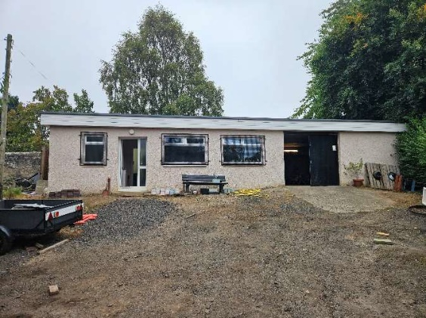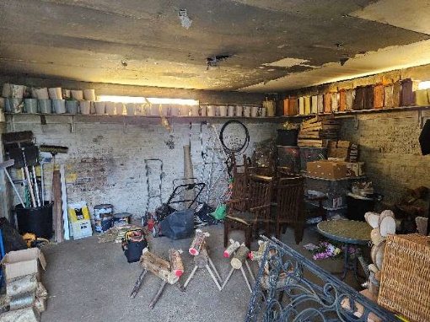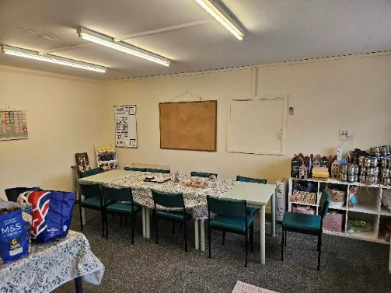
Yard Facing West Workshop General Purpose Area
Address: Bo’ness Cemetery Bothy, Dundas Cemetery, Bo’ness EH51 0DG
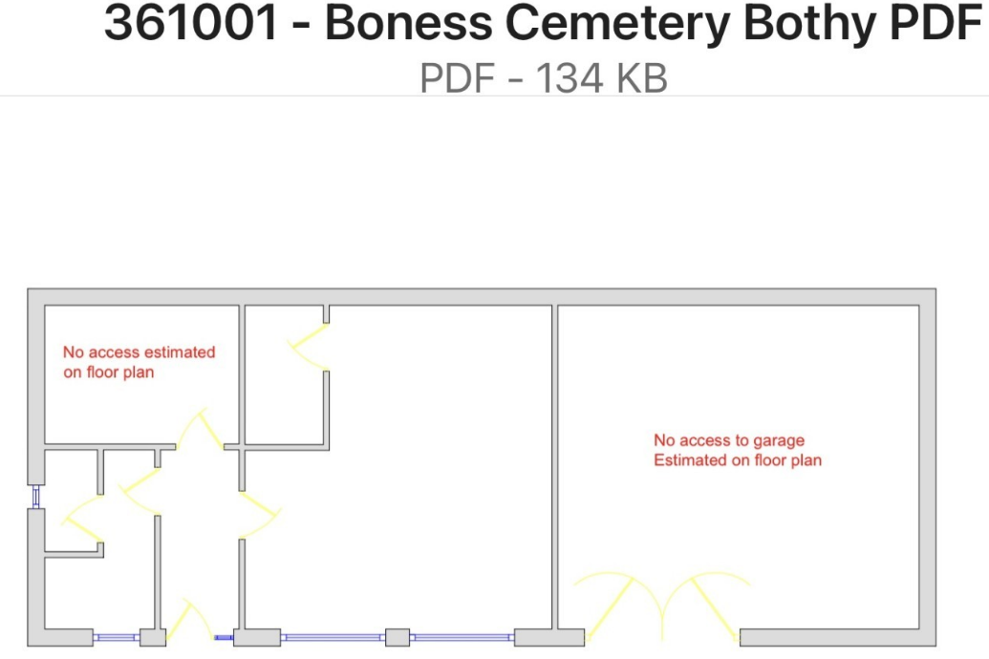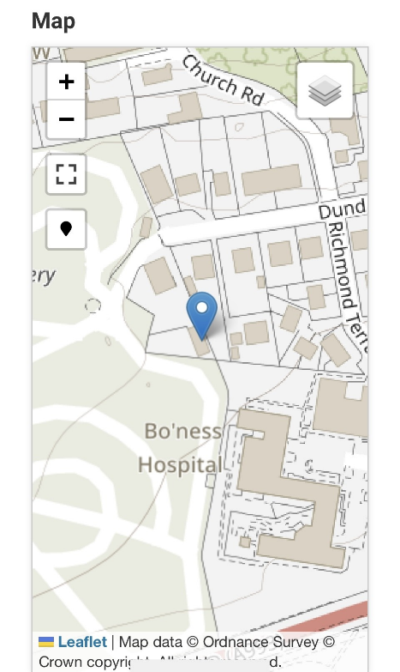
Footprint of Bothy
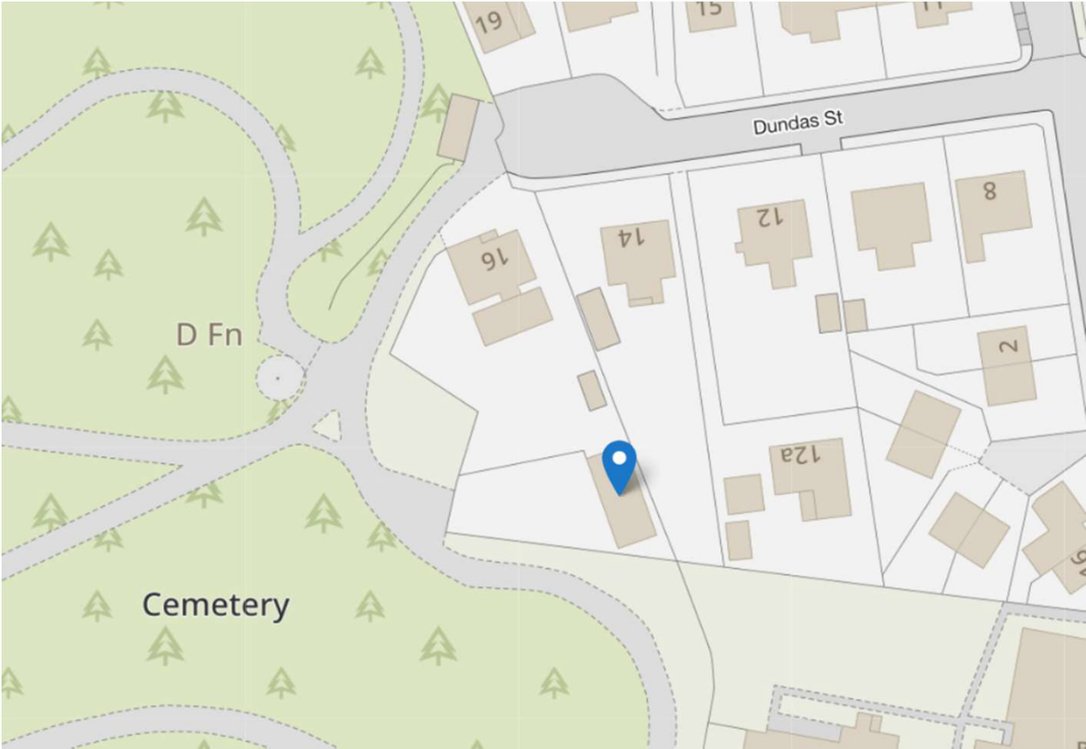
The property is situated at the North East side of the cemetery approx 70M from the Dundas street entrance.
  - Please provide the UPRN (Unique Property Reference Number), if known.

UPRN:136079043

Section 2: Type of request, payment and conditions
  - Please tick what type of request is being made

for ownership (under section 79(2)(a)) - go to section 3A – this box has been ticked

for lease (under section 79(2)(b)(i)) – go to section 3B

for other rights (section 79(2)(b)(ii)) - go to section 3C

3A – Request for Ownership
What price are you prepared to pay for the land requested?
Proposed price: £1
Please attach a note setting out any other terms and conditions you wish to apply to the request.
We would like to take ownership of the Yard

3B – Request for Lease
What is the length of lease you are requesting?
We wish to own the building and yard

How much rent are you prepared to pay? Please make clear whether this is per year or per month.
Proposed rent: £ per
Please attach a note setting out any other terms and conditions you wish to be included in the lease, or to apply to the request in any other way.

3C – Request for other Rights
What are the rights you are requesting?
We request the permanent right of access to the bothy from the Yard via the Dundas Street gate

Do you propose to make any payment for these rights?
Yes ☐
No ☐
If yes, how much are you prepared to pay? Please make clear what period this would cover, for example per week, per month, per day?
Proposed payment: £ per
Please set out any other terms and conditions you wish to apply to the request.
In order to make the asset perform to its greatest potential we need full use of the gated entrance and the yard. Our plan is to have the 2 metal containers removed and to flatten and resurface the whole area giving us parking spaces and ensuring a safe access/egress for visitors. If we are to move forward with having the various activities, classes and workshops we have planned within the bothy it’s important for the yard to be cleared and to allow cars to park safely and out with the paths in the cemetery. Because of the location of the Bothy we have to be extremely sensitive to people visiting the asset and it is imperative that our neighbours are not impacted. As can be seen by the image below there are 2 large metal shipping containers in the yard and it has been allowed to become extremely overgrown and unsightly. Once this is cleared and the uneven ground is levelled it will enhance the whole asset.
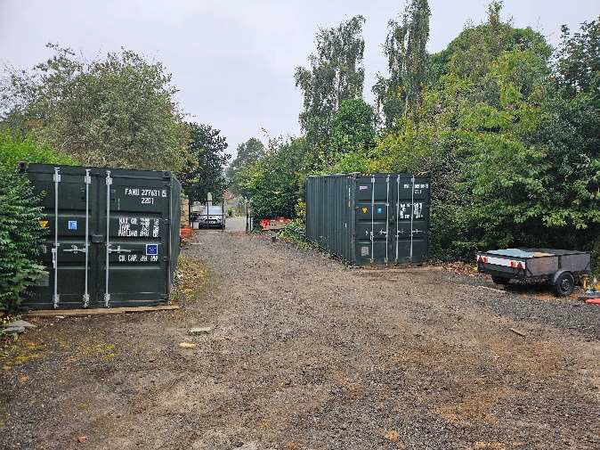

Section 2: Community Proposal
  - Please set out the reasons for making the request and how the land or building will be used.
This should explain the objectives of your project, why there is a need for it, any development or changes you plan to make to the land or building, and any activities that will take place there.
4.1.1 Objectives of Project
In its current format Bloomin Bo’ness was formed in 2021 after the global pandemic when the town of Bo’ness along with the rest of the world was coming out of lockdown with the objective of tidying up the flowerbeds that had been left to become thickets of weeds. Prior to this the local authority had withdrawn gardening services to all the various towns in the Falkirk District and some volunteers had planted the flowerbeds with plants provided by the council. 2022 saw a complete withdrawal of all help. Bloomin’ Bo’ness started off with absolutely no money but a strong desire to regenerate and beautify the flowerbeds and other areas that were sadly neglected and a complete eyesore. We asked for help from the community and found very quickly that people coming outdoors to garden was a safe activity which allowed social distancing and with the help of donations of equipment and decoration through advertising on social media and hard work we created our first community garden which we called The Bugness Community Garden. This is our third full year and our objectives have remained the same. We wish the town of Bo’ness to be considered among the best in the district, a place where locals and visitors can enjoy our eclectic and interesting displays and provide an open door for volunteers from all age groups and abilities. We are now in a situation, where we require a safe, clean and serviced premises in order that our members and wider community can have somewhere to store our tools, equipment and decorations and further more a place where we can hold workshops, invite speakers and have meetings. Having the bothy will open so many doors to new resources for us and we see it as the icing on the cake.

Our main purpose is below

The organisation’s purposes are: The advancement of environmental development and improvement within the town of Bo’ness
The advancement of community engagement and development.
The advancement of education
And in furtherance of these purposes, it will
Undertake community gardening and improvement projects
Actively engage members of the community in these projects
Fundraise to support these projects

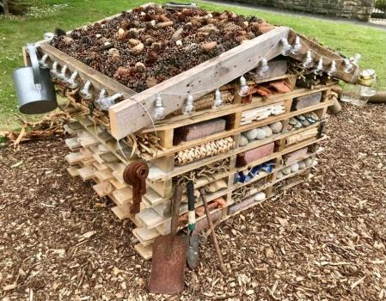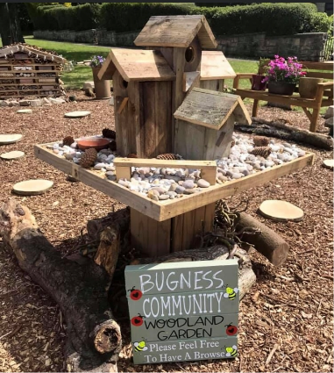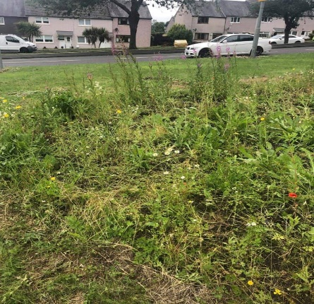
BEFORE

The Bug Hotel and the Bird Feeding Station in the Bugness Community woodland garden – our very first project. Made from donated pallets, an old gate and other things from the community.

We were recognised by CVS for the above project and they did an article promoting our work which can be found in the addendum

This is the objectives of our project.
.

4.1.2 Why there is a need for your Project?

As previously mentioned, the Local authority namely Falkirk council no longer do any gardening across the full district and it is therefore the responsibility of each town – if they choose - to keep their towns flowerbeds and public areas looking cared for and beautiful. As our group undertook more and more projects and further volunteers came on board it became quicky apparent that we needed a premises to store our equipment and somewhere we could group for meetings and to make decorations for our displays. We have through fundraising and donations accrued a fantastic array of tools and display items all of which are now safely and carefully organised in the bothy. Members can access the equipment as they need it and we have a safe and functional space to have meetings, host events, run community classes and much more. We are in a very different situation from most applicants as instead of what we do happening inside the asset, we rely on the asset to make what we do in the community successful, and we ask that the committee approach our application with this in mind.
This is why there is a need for our project.

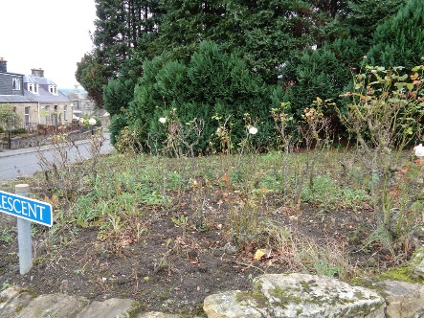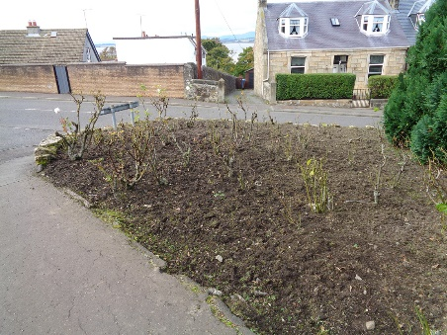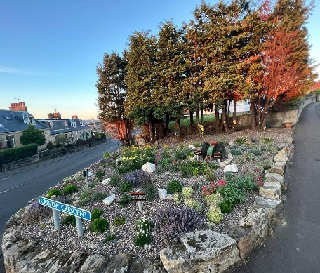
Cadzow Corner before, during and after. This spot is on the main road driving down the hill into the town centre and was a weed choked eyesore.

This one was completed in 2023 – planned by us with a country cottage theme complete with a beautiful vintage thresher. We did this working alongside the council community growing officer – once completed it was filled with pollinators and is buzzing thriving joy every year.

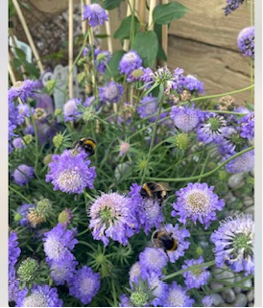

Happy Bees

4.1.3 Will any Development/changes/modifications to the asset be required?

There are a few modifications which would be advantageous to the asset, namely the yard would benefit from being landscaped with Monoblock or something similar – our main reason for asking that the yard be included with the asset is so that we can have ample room for parking and keep any traffic visiting or using the bothy away from the paths in the cemetery. The vegetation has been allowed to become
Completely overgrown and would benefit from a really good cut back.
We definitely need to improve the exterior lighting with motion sensor floodlights. On the whole the Bothy is in good condition and save for a few cosmetic touches is pretty much ready to use.
These are the changes, modifications that are needed.
4.1.4 What activities will take place?

Our vision for the bothy underpins everything that we plan to do in the town. Without the asset Bloomin’ Bo’ness quite simply could not achieve the projects and the work we do. We have more credibility in the fact that we have been awarded the lease and it proves to us that the council take us seriously and recognise our efforts and achievements. Inclusion is at the heart of everything we do and with this in mind we would like to offer workshops and classes for the community to learn various skills such as making hanging baskets, holly wreaths, decorative paving slabs to name a few ideas. We already have a book club which meets here monthly for a nominal fee and this is something we would love to expand upon. Our volunteers are already using the space to create and store finished decorations including reindeer and various other seasonal decorations. We had a stall at a local craft fair recently and the bothy was used for our members to create crafts to sell. Bloomin’ Bo’ness are a relatively new group and we have achieved so much in the three years we have been together. We deserve a decent premises that allows us to function to the best of our ability and this in turn will allow us to the best for our town whether it be maintaining what we already have or having decent facilities for planning and executing new projects to keep Bo’ness Bloomin’

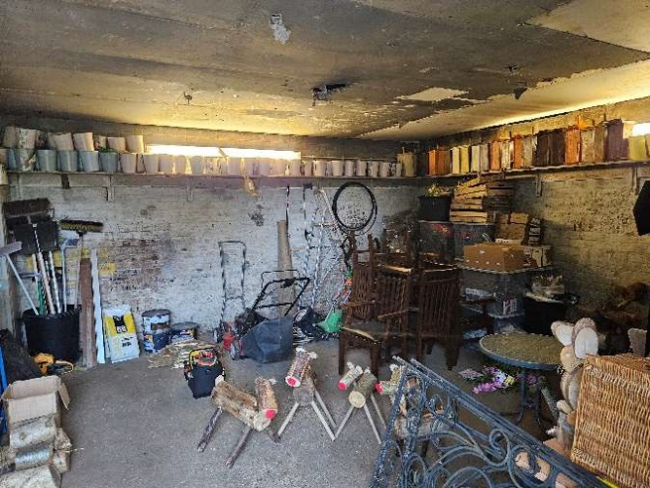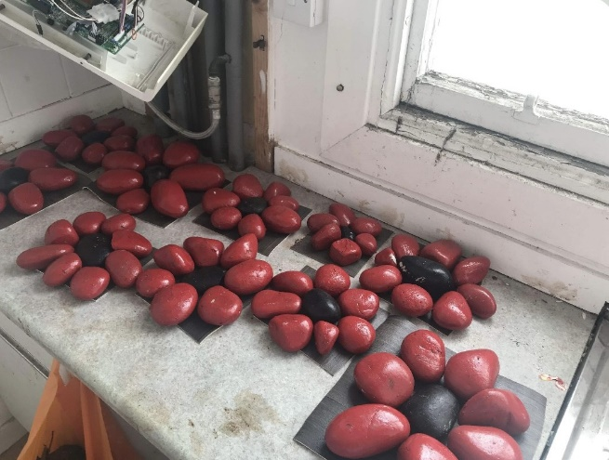

Newly built reindeer ready for our Rock Poppies for the Cenotaph all made
Festive displays. In the bothy by our volunteers and
Children in the community.

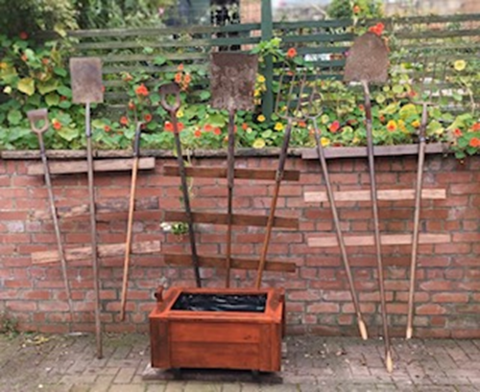
Trellis made from Old garden Tools

These are the activities that will take place.

4.1.5. If the asset is to be used by the public, please provide details of lettings policy and opening times.

A local Book Club currently hold monthly meetings here and this is something we
wish to expand upon and we certainly want to actively encourage other groups to
Use the Bothy for similar activities. Our key holders have agreed to open and
Close as required. Once we undertake our various craft classes workshops and
Events these will be advertised and of course the person running the event will be
On hand to open and close. Going forward if we begin to have longer term lets
With groups we trust then it may be worth considering allowing groups to have
Keys. We conducted a facebook poll to gauge interest and we were pleased with
The people who responded saying that they would attend our classes.

[IMAGES REDACTED]

One of the questions in our poll was whether or not people would attend classes, in the bothy and use the meeting rooms and we received an overwhelming yes.

4.1.6 What provision will be provided for people with disabilities?

The yard is on a gentle slope but it is uneven in places and therefore trying to
Push a wheelchair up to the door would be difficult. We do wish to take the yard
As part of the asset and would look to completely Monoblock or another flat
Surface – looking forward if we were successful in securing the yard a ramp
Would certainly make sense as there is a step up to the door.
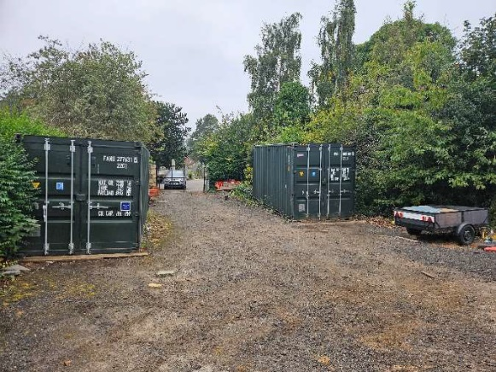

The yard is on a slight slope and is uneven

These are the provisions that we would make for disabled users

Benefits of the proposal
  - Please set out the benefits that you consider will arise if the request is agreed to.
Local Authorities are permitted to dispose of property at less than market value where there are wider public benefits to be gained. This is set out in the Disposal of Land by Local Authorities (Scotland) Regulations 2010. These public benefits are listed below.
In this section, please explain how the project will benefit your community, and others. Please refer to the Scottish Government guidance on how the Council will consider the benefits of a request.
Please explain how the project will benefit your community by detailing how your project will promote or improve:-

4.2.1. Economic development/income generation
ie. Please include details of any job creation or volunteering and training opportunities that will be available as a result of the Asset Transfer. Also details of how your organisation will involve the local community and of any incentives that may be available to encourage the local community to use the proposed services.

The bothy is the ideal premises to host training workshops, indeed without it we could not even begin to consider these as a remote possibility. We have recently added a community liaison officer to our group of volunteers and her role is to reach out to schools, nursing homes, guides, brownies, scouts etc and find out the ways we can be inclusive. Some of our volunteers have specialist skills that can be passed on and we fully intend to utilise these by way of workshops and open days.

We use social media as an advertising tool and have found that this is an excellent way to advertise our events – we incentivise local engagement with various seasonal events such as asking children to post a picture next to our easter displays and delivering easter eggs to them and asking the children of the town to make handmade decorations for the Christmas trees we have on display every year.

The bothy is for groups to hold meetings and this is something we wish to encourage from the get go. The book Club already hold meetings there and we are in talks with another group for a similar function. We already call the big room Multi-Purpose because already it is used for so many different things.

It is difficult to forecast or speak of economic development\income with regard to the benefit our asset will bring however we truly believe that Bo’ness is a far more beautiful town than it was only a few short years ago and with the added benefit of at least 60 local businesses sponsoring our displays and features it stands to reason that when folk see these they may be inclined or encouraged to support locally.

People visiting the town will explore our various sites and hopefully they will spread the word and in turn that will bring footfall into the town for local businesses.

We are also in the process of having an APP developed with one of the features being a map of the locations of our various displays to visitors can see at a glance where to go to look at everything. We intend to have a link for events, classes and other information accessible to all and free for everyone to take part.

https://bit.ly/bloominapp

Or use the QR code for direct access



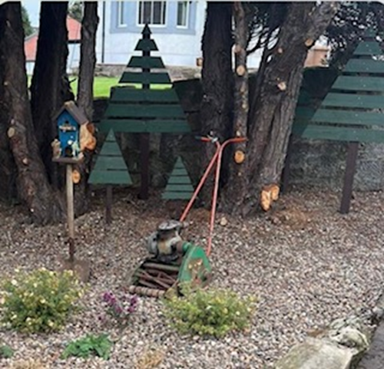
Trees and Birdhouses made by our talented volunteers and a donated vintage
Mower

That is how we see our project adding to the economic and development of our community.

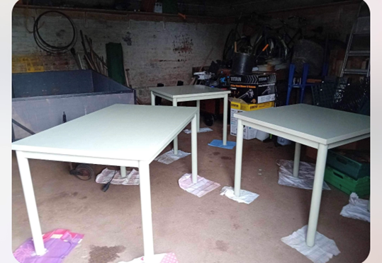

Donated tables being freshened up to be used in our all-purpose room.

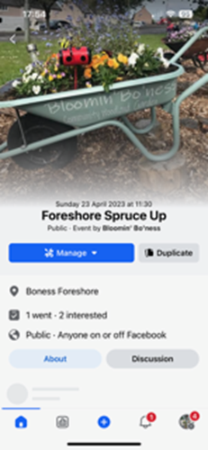

We advertise all events and ensure everyone is made welcome

    - Regeneration

i.e. Please include details of whether your organisation will contribute to the physical regeneration of the area, and how your proposal will impact the regeneration of the area, in terms of volunteering or employment, giving examples.

It is difficult to convey the response we have had in the town from locals and visitors alike. We have fundamentally changed the landscape of our town with our innovative work and this is endlessly commented on and admired. We pride ourselves in the fact that we are forever finding new areas to develop and this of course means that we can offer more volunteers to get on board. Many of our projects have brought back to life previously neglected and or barren areas that are now firm favourites with local and visitors. The local nurseries love the woodland garden and the bug hotel and the children can often be seen walking back from the woods after gathering pine cones to put in the bug hotel.

Many people have told us that friends and relations from outside Bo’ness have commented on the difference in the town and how wonderful it is to see previously abandoned unkempt areas buzzing with life which is not only beneficial to the environment but for those who like to walk around and enjoy it. Regeneration also makes the town more attractive and a nicer place to live/visit.

The chairman of the Bo’ness Fair asked our group to provide floral decoration for their staging on the Fair Day and this was seen and enjoyed by thousands on the day not only in the town itself but beamed all over the world. This is something we absolutely could not do without the bothy. With respect to the above having the bothy elevates us from being able to do some things but being limited, to being able to undertake projects no problem as we now have the space and the support to do it.

[IMAGE REDACTED]

An interactive map of all our locations and The Local Nursery Visiting the Bug House with pictures they had made.

This is our idea of positive regeneration.

    - Public Health

i.e. How likely is the proposal to improve the Public Health of the Community, in terms of physical and mental health, for example through volunteering, training, or taking part in activities, giving examples.
One of the best things anyone has said to me is “No matter how bad a day I'm having, driving or walking past the displays makes me smile and feel happy”

We have tried to make it so that most areas in the town have something good and interesting to look at and try to keep our work near pubic roads and footpaths so that they can be enjoyed by everyone. A common misconception about our group is that you have to good at gardening, but we are always keen to dispel this and stress to everyone that what we do isn't about gardening at all. It’s about coming together as a group of people with a common goal, trying our best to make our town look better, involving people who perhaps suffer from social isolation and making friends and having fun along the way. Being outside and immersing yourself in gardening or indeed any pursuit all is extremely good for your mental and physical health. Indeed since 2019 the NHS have been “social prescribing” as part of their long-term plan and I know firsthand that our local practice has certainly referred patients to us to become involved in whatever capacity they feel comfortable with. We are quick to point out to everyone that no matter what time you can give or what skillset you have you will be needed and wanted in our group.
There is nothing more rewarding that seeing a previously shy, anxious volunteer grow into being a main player in the team, leading projects, taking charge and having the confidence to move projects forward without interference or input from us.

[IMAGES REDACTED]

Walking around visting our beautiful areas improves the metal and physical health,

We have thousands and thousands of examples of these lovely comments

We encourage everyone to join in and this is how we envision improving public health

    - Social Wellbeing

i.e. How will the proposal improve the Community's Social Well-Being and mental health, or how might it improve the learning offer and activities available in the area? Please give brief examples of these activities.
There are a few local businesses in the area that offer craft classes and meeting rooms but these can be expensive. We at Bloomin’ Bo’ness hope to offer our classes and workshops at a very reasonable rate which will benefit those who wish to take part but find the expense of commercial classes off putting. By offering reasonable rates for group interaction, we would hope to improve the potential for learning. We haven't completely decided but we will certainly be offering classes to make seasonal decorations such as hanging baskets, wreaths, garlands etc. We are keen to emphasise that Bloomin’ Bo’ness is so much more than gardening. It is about nurturing a sense of pride in the place where we live and many many people who have joined us say that they would not have ventured out to do things on their own but doing things as part of a group is much easier and there is no pressure to do anything other than what they are comfortable with. In terms of social well-being, we intend to ensure that our classes and opportunities to volunteer are open to everyone and we will always explore the possibility that those who attend our classes may wish to become volunteers or friends of Bloomin’ Bo’ness
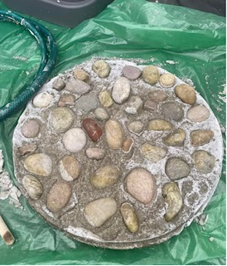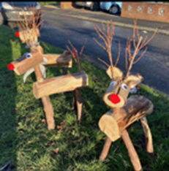
Examples of Crafts we wish to teach.
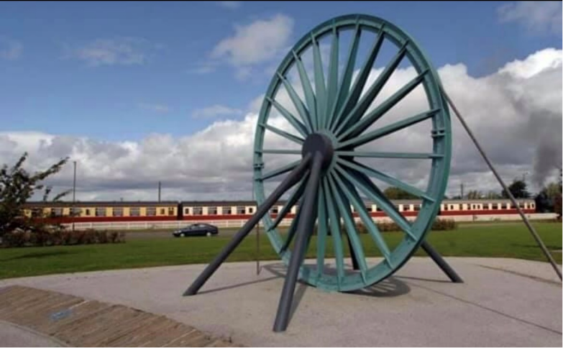

We also use our funds to commission local businesses to maintain areas in the town that attract tourists such as the miners’ memorial – previously this was chock full of weeds and absolutely filthy – a disgrace to the men who worked the mines.
It is now spotless with lovely filled tubs.
This is how we intend to maintain social inclusion and wellbeing.

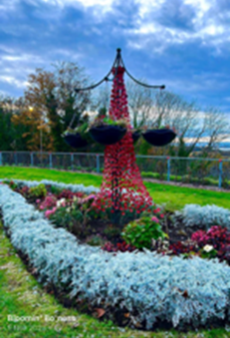

The war memorial is our pride and joy and we ensure that it is befitting of the sacrifice the men on the monument made. We encouraged the local children at the primary schools to paint stone poppies in tribute to the men, and were delighted to see them not only participate but to bring their family members down to the memorial to see the poppies they had painted.
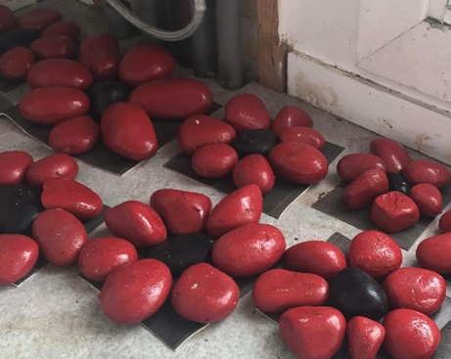

The local children loved painting the poppies for Remembrance Day and were interested to learn from our volunteer Christine – a local retired librarian and historian, of the story of why the British Legion has adopted the poppy as their emblem.

    - Environmental Wellbeing / Environmental Benefits

i.e. Will the proposal bring green / environmental benefits and / or have an impact on the local environment? Will it help mitigate the effects of climate change? If so, please give details.

Aside from all of our sites being Zero waste we encourage and promote where possible the use of organic materials and our ethos of reduce reuse recycle is evident across all our displays with upcycled artefacts and items forming the back drop of most areas.

As previously mentioned, our work has brought previously abandoned areas back to life with flowers, growing food, plants and wildlife: due to our commitment of planting bee friendly pollinators, and this is no more evident than at the old tennis court abandoned for 30 years at the back of Bridgeness Bowling Club. The site was under 2 meters of thick weeds and waste. We cleared 16 tonnes of rubbish from the whole area and it is now home to our 8M Carbon fibre polytunnel where we have tentatively started growing our own plants to use in our various areas across the town. We approached the Local Steam Railway and they allowed us to take 140 Victorian railway sleepers from their yard that had been lying unused for 25 years. These are now 11 Stunning raised beds that members of the community can lease on a yearly basis and grow Vegetables and Flowers. We have a thriving composting area complete with a wormery and each year after Halloween we have a “Don’t dumpkin your Pumpkin” scheme where the community are invited to bring their used Halloween pumpkins to the site where they are used for composting. All of our composting bays were built using recycled fencing and we plan to use more of this wood to erect a lean to in order that we can assemble guttering to collect water in 5 water butts.

During the summer one of our volunteers who is a scout leader brought her troop along to the community garden where they loved seeing the vegetables growing, the wormery, the composting and looking at the newly erected polytunnel. We put them to task by asking them to go away and collect organic materials to come back and erect a bug hotel from our stash of old pallets.

None of this would have been possible without the bothy as the asset was used as a hub for storage, meetings, planning, deliveries, charging batteries for tools and much more.

We intend changing the lights in the Bothy to LED and will look toward installing a couple of water butts here also. In terms of sustainability the Bothy will be run as environmentally friendly as possible. It is a zero-waste facility and everything we have brought in so far in terms of furniture is donated. We are conscious that resources are precious and we pledge that will always look at ways to leave a smaller footprint where we can. In our opinion the Bothy was not being utilised to its full potential by the council. When we applied for the Bothy under the SPR scheme we were met with resistance from the current users and it was arranged that we split the building until the CAT was complete. The service users who currently share with us have been found to have the heating on round the clock for days at a time and we have had to report this at least 6 times. We see this as a very wasteful misuse of the councils’ resources. Furthermore, we will apply our own ethics to the bothy therefore the heating will only be used frugally if at all. [IMAGE REDACTED]

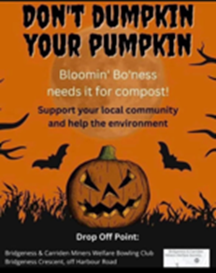
Preparing Old Sleepers for their new home We use the pumpkins for compost

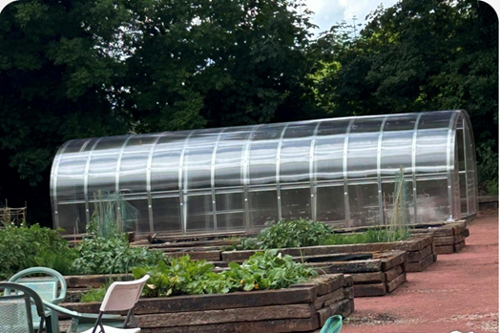 [IMAGE REDACTED]

A post to gauge interest
Our fabulous community garden and polytunne

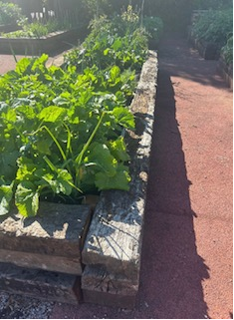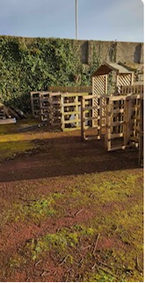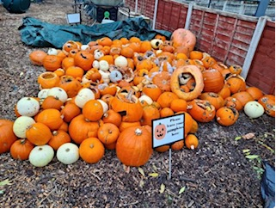
These sleepers lay in the Railway yard for 25 years, now they are raised beds. Our composting areas built with old fencing. Our pumpkins from the annual
‘Don’t Dumpkin your Pumpkin Scheme’

This is how we shall address environmental wellbeing for our group.

    - Does your project contribute to the reduction of inequalities?

i.e. Will the proposal enable the community to access activities not otherwise available; will these activities be available at an affordable rate; how will your organisation work with other local providers to reduce inequalities?

Most of our volunteers do have their own garden but also like to be involved in being out and about helping across the community. Some of our volunteers suffer from social isolation and being among the rest of the team can often be the only other contact they have. It is essential for us to have the asset to support everything we do and we cannot highlight enough how important it is to provide our members and friends with a base where they can access supplies, join in classes, come to meetings and work away themselves or be teaching in the workshop. We have over two thousand followers on social media and frequently advertise for volunteers in any capacity and have never turned anyone away who offers their services. We are looking forward to welcoming to our bothy to people from all walks of life to take part in our workshops and classes and if they wish to become volunteers even better.
We are a socially inclusive organisation and everyone is made welcome regardless of disability, race, sexuality and gender.

We are a wholly inclusive organisation and strive to reduce any inequalities.

4.2.7 Will local people be engaged in the use and management of the Asset?

A “community of interest” may not represent the people living near to the asset. Please provide evidence of how local people and communities will be engaged in the use and management of the asset, and how they have been consulted.

Everyone who uses the asset will be local and we have already introduced ourselves to our two closest neighbours who are absolutely delighted we are using the Bothy for the purpose of supporting Bloomin’ Bo’ness. Before we began our journey with the application for the Bothy we spoke to our members and asked if they thought the bothy would be beneficial to the group and found that this was on overwhelming yes. We have so much talent in our group of members and we are looking forward to seeing them flourish in this exciting environment. As per our constitution any local person can become a member and therefore offer suggestions, that can be considered and potentially taken forward.

This is how locals will be engaged and can help the asset.

4.2.8 How will you monitor whether the Asset Transfer is benefiting the community?
There is evidence already that the asset is benefitting the community, the very fact that we have been able to undertake tasks that we would have previously have had to say no to is very real. We plan to have an open day and introduce anyone who wants to pop down and see the bothy and take some information away regarding what we do and what the bothy will be used for. Information that will also be on the app so everyone can be

This is how we monitor whether or not the asset is benefitting the community.

4.2.9 Any other relevant information?

Although most of our work is achieved and displayed out with the Bothy it is important not to underestimate its importance in terms of enabling us to carry out the work, we are able to produce for the flower beds and other areas in the town. Quite simply we would not be able to effectively carry out the work we do if we did not have the confidence of having the asset which to us is so important that it’s impossible to see how we could manage without it. I really feel that we deserve to have this asset as we struggled for 3 years having our tools and other equipment scattered around, not knowing where anything was, losing equipment etc everything seemed much more difficult and we relied on people's generosity to store things and when you consider how quickly we have expanded and the amount of tools and equipment we have this was simply not fair on our volunteers who give their time and effort and should not be expected to be used for storage too. Most of the craft items were made in homes as were all the sponsorship signs and it quickly became apparent that this could not continue. We see the Bothy as the prop that holds us up and allows us to do what we do in the community, gladly giving up our time and effort as volunteers without it having to infringe on our own homes and life.

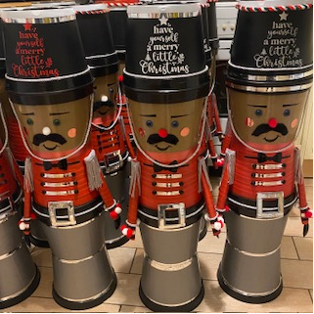

All of this was made in a trustees own home last year which was inconvenient and stressful.

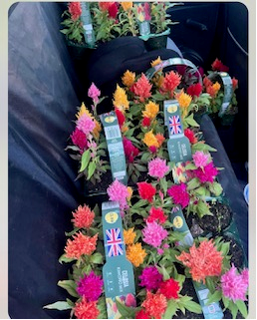

We no longer have to collect
Plants in volunteer’s cars as
The Bothy allows us to
Keep a trailer.

Restrictions on use of the land
  - If there are any restrictions on the use or development of the land, please explain how your project will comply with these.
Restrictions might include, amongst others, environmental designations such as a Site of Special Scientific Interest (SSI), heritage designations such as listed building status, controls on contaminated land or planning restrictions.
We are asking for access through the western gate of the cemetery and we wish to have full and exclusive use of the yard as we need the bothy to be fully accessible for our volunteers and all users especially those with disabilities in particular wheelchair users who require a safe, flat terrain with the vision of resurfacing the yard and installing a ramp.
Negative consequences
  - What negative consequences (if any) may occur if your request is agreed to? How you propose to minimise / reduce these?You should consider any potential negative consequences for the local economy, environment, or any group of people, and explain how you could reduce these.
We are in a situation where the FC bereavement services still use the back room in the North section of the bothy and still use the yard where 2 metal containers are used for storing their equipment. We have had significant issues with the service leaving the heating on constantly in their part of the bothy and have had to tell the council in no uncertain terms we are not responsible for a share of the cost of this. The service has asked to retain the yard however Bloomin’ Bo’ness strongly feel that we should be granted sole use of it as we would like to landscape it to use as a carpark for members and visitors. On numerous occasions we have had to contact Bereavement services about the disgraceful state the yard is kept in by the service. Before our complaint there was bags of their litter including food waste that was scattered all over. The trees and foliage of the yard are massively overgrown and it is apparent that the service does not have a vested interest in keeping the yard looking tidy and well kept. My understanding is that the plan is for bereavement services to be centralised which suggests to me that they will still have somewhere to store equipment and the bothy and yard will be far better utilised when Bloomin’ Bo’ness have ownership as sharing is already proving very difficult owing to the reasons stated above.
The bothy is open at the back to 2 of the houses on Dundas Street and we have already spoken to the neighbours in both the properties explaining who we are and what we are doing. One of the neighbours is actually a friend of Bloomin’ Bo’ness and makes yearly donations to us as she is so pleased with the difference we have made to the town.
We are already massively aware that parking has to be very sensitive especially since the asset is in a cemetery therefore, we currently park in Dundas Street which is a very short walk to the bothy and has plenty of parking options.
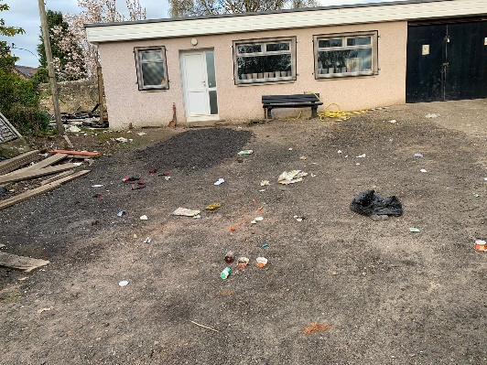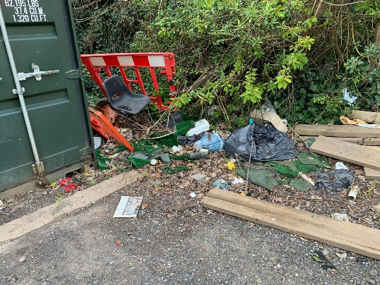
We have had to complain several times about the yard – bags of rubbish and overgrown foliage.
Capacity to deliver
  - Please show how your organisation will be able to manage the project and achieve your objectives.
This could include the skills and experience of members of the organisation, any track record of previous projects, whether you intend to use professional advisers, etc.
4.5.1 Has your organisation or any of its members managed projects or owned / leased property/land prior to this.
Our current secretary has previously secured a community benefit lease for the public toilets which have been instrumental in benefitting the community for 18 months now – this was received with enormous support from the town and [REDACTED] organises and ensures the smooth running of the assett. We currently hold a community benefit lease for the cemetery bothy and are proud of what has been achieved here already.
Yes ☐yes
No ☐
Please provide details of:
4.5.2 Skills and experience of the members of the organisation
Our members are from all walks of life and bring an array of skills that have transformed the landscape of the town of Bo’ness. Some of our members are retired and their skills include an engineer, quantity surveyor, civil servant, builder, painter and a joiner. Most of our volunteers commit to our group with a genuine passion for becoming part of the difference that is taking place within Bo’ness. As well as volunteering in the community some of our volunteers have taken on roles such as Community Liaison Contact, Sponsorship Co-ordinator, Community Payback Liaison Contact, Grants & Funding Caretaker, SCIO Compliance Officer and we have just given one of our volunteers the title of Keep Scotland Beautiful Application Officer as we are geared up to enter the competition in 2025.
The truth is none of us are qualified gardeners, we do however have a genuine desire and unswerving energy in the upkeep and expansion of the works we have achieved so far. When the two founding members discussed perhaps having the polytunnel at the old tennis court in Bridgeness it was a complete pipe dream but we made it happen by sheer determination, tenacity and an unrelenting resolve to achieve it. This is the way with everything we do, we have a complete ‘yes we can’ attitude to everything we undertake and sheer drive, will and determination gets it done.
We are a very tight unit and those who want to, are part of a Messenger group chat which buzzes with conversation and ideas most days. Now that we are a registered charity our constitution dictates that we must hold regular meetings and the Bothy is absolutely ideal for this, being safe with a working toilet and tea and coffee facilities.
This is the skills and experience of our volunteers.

4.5.3 Do you intend to use professional advisors? Please provide details.
We intend to use a Lawyer from Liddle & Anderson Bo’ness and an Accountant [REDACTED] from Alan Steele Linlithgow.
4.5.4 Do you currently lease/manage a property from Falkirk Council? If yes, please provide details.
We currently hold the lease for the Bothy
4.5.4 Please detail how you plan to manage the building.
We have 4 Keyholders at the moment and have already developed a system where others can access the building as and when they need to. It is not foreseen that we will need to issue keys to groups having meetings or classes as we feel the members who have keys will be happy to accommodate these. Once we have established users, we can decide then whether or not trusted users can have keys.

4.5.5 Please provide any other information you think may be relevant.
We have deliberately not spoken much about the 12 areas we have developed and continue to maintain as it is important to understand and for us to emphasise that having the Bothy is now more than ever at the core of everything we do. We are in a unique position within our application in that it is not a community centre we are trying to secure so having to explain why the bothy is so relevant to 12 sites out with its boundary has been a challenge. We are excited that we hold the lease for the Bothy and this has already had an invigorating effect on our members and the way we do our business – to say that it has transformed the groups capacity to deliver even more beautiful projects would be an understatement.
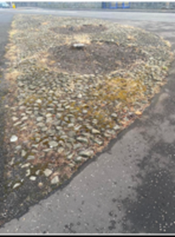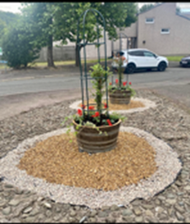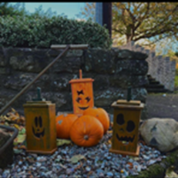

Before and After on Dean Road Bo’ness - then all ready for Halloween.

Section 2: Level and nature of support
  - Please provide details of the level and nature of support for the request, from your community and, if relevant, from others.
This could include information on the proportion of your community who are involved with the request, how you have engaged with your community beyond the members of your organisation and what their response has been. You should also show how you have engaged with any other communities that may be affected by your proposals.
5.1.1. What community engagement has taken place to help develop your business plan? Please provide evidence, for example any completed surveys, questionnaires, letters of support, minutes of public meetings etc
We engage with the community mostly using Social Media and have a thriving Facebook page that we use to promote and brag about our group. We undertook a poll over the community pages and were delighted to find that the community are supportive of us applying for the Bothy as a CAT and we look forward to sharing the building with everyone once we secure the asset. After 1 day we had well over 2000 votes across the 4 questions we asked. This together with the testimonials and the comments from the poll we will share with you from the people in the town hopefully let you see what an asset we are to the town.
RESULTS OF OUR POLL

Please click the link to engage with the Poll
https://www.facebook.com/share/p/15DECsJh2m/?mibextid=WC7FNe
[IMAGES REDACTED]

We had over TWO THOUSAND votes in 2 days

Please also find some examples of comments made on our poll.

[IMAGES REDACTED]

5.1.2 Have you consulted with other local stakeholder groups or agencies? Please provide evidence
5.1.4 Have you been in contact with any other communities or community groups that may be affected? Please give details
We already work very closely with the community clean up group, indeed some of the volunteers cross over to both groups therefore it makes sense for us to pool resources and ideas. The community payback team have been fabulous in clearing and reducing heavy growth on areas that are a bit beyond our skills
5.1.5 Please provide any other information you think may be relevant.

Section 6: Financial Viability of Project
Your Business Plan should contain full information about the financial viability of the project, evidencing that the organisation will be able to sustain the project in the long term.
Please submit
- at least 1 year’s audited accounts to evidence your organisations financial stability (if available)
- where audited accounts are not available (for instance for new groups) please provide a bank statement.
- a projected 5 year income and expenditure account
- a cash flow forecast for the proposed asset transfer.
6.1 Please outline the Policies and Procedures your organisation has in place to govern the group’s finances
Bloomin’ Bo’ness were delighted to be awarded charitable status in March 2024, part of this determines we must submit audited yearly accounts. We have an accountant on standby for this. Our treasurer is vigilant in his book keeping and we are meticulous and scrupulous in ensuring everything is in order. Please find a copy of our bank statements attached. Now that we are a charity there are many more schemes and sources of funding we can apply for and we work with CVS and the council to keep up to date with anything that may be coming up.
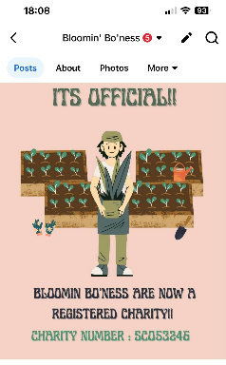
We were awarded charitable status in March
These are the policies and procedures we have in place.

Section 7: Funding
  - Please outline how you propose to fund the price or rent you are prepared to pay for the land, and your proposed use of the land.
If you intend to apply for grants or loans, you should demonstrate that your proposals are eligible for the relevant scheme, according to the guidance available for applicants.
7.1.1 Please show your calculations of the costs associated with the transfer of the land or buildings and your future use of it, including any redevelopment, ongoing, maintenance and the costs of your activities. All proposed income and investment should be identified, including volunteering and donations.
Please refer to the financial appendix sent separately.
7.1.2 Please supply details of what funding you have received so far, and of any conditions attached to it.
We have not need funding for the bothy as the building is in good sound condition.
When Bloomin’ Bo’ness (in its current format) started in 2021 we had absolutely nothing except a determination and desire to make the town of Bo’ness look cared for and vitally a place where the folks that live here could be proud of. What I find it difficult to convey is exactly how far we have come with very little money. We made the provost road garden with absolutely no money, just donations from the community and we raised funds for the roundabout by selling tickets to “Name the Boat” which gave us enough funds to completely transform the roundabout and the 6 beds at the foreshore. Since then we have gone from strength to strength with our sponsorship scheme and donations from the public but genuinely at heart we are still very frugal and always ask for second hand before we buy anything.
[IMAGE REDACTED]
Our very first attempt at testing whether the community trusted us enough to take part – it was an overwhelming yes with almost £800 worth of tickets so
Most of our funding so far has been geared toward the work that we have undertaken in the community and the development of the community garden – we are in the very fortunate position that many of the local businesses in Bo’ness have been extremely generous to us with donations. We refer to these people as ‘Friends of Bloomin Bo’ness’ and they contact us to say that they have had a fundraiser or event for us or that they wish to make a donation. These are people like Branches, BRAAS, Bo’ness Belles, and several other kind donors.
We have also been successful in securing funding from Tesco and Miller Homes so far. Our main source of income is our sponsorship scheme which is broken down into 12 areas plus the community garden. We renew this scheme annually and charge a modest fee for the sponsor to have a customised plaque beside the feature they are sponsoring – we have just finished our third year and the response to it has been phenomenal. We have over 140 separate sponsors distributed over the 12 areas and there is a waiting list of names for next year in the hope that we have new areas ready. There is a mix of business, private, charity and memorial plaques. Such was the success of this scheme we advertised and were successful in finding a volunteer to completely manage it which has enabled us to streamline the process far more effectively which is beneficial for everyone. The volunteers in our group make the plaques and again this is something that can now be done in the Bothy instead of asking our member to do it in their own home.
[IMAGE REDACTED]
Our sponsorship signs are made in volunteers' homes which is inconvenient and can be messy.
[IMAGE REDACTED]
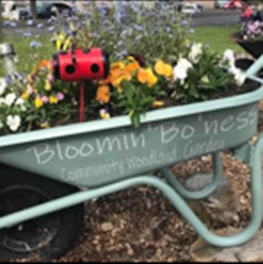
One of our sponsors who joined in year 1 and is still with us year 3

Some of this income will of course have to be considered for the upkeep and running costs of the bothy as we see it, that the bothy plays an integral part of what has so far, and will in the future, make us so effective, however as previously explained we to do intend to hold classes and events and charge a nominal fee for these to ensure that the bothy can be self-sufficient in terms of anything we wish to purchase for it.
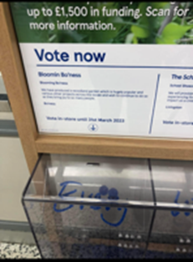
[IMAGES REDACTED]
We have been humbled and thankful that we have so much support in the community. It has been suggested to us that we can perhaps begin to sell vouchers for an area to sponsor – these could be given as Christmas or Birthday gifts.

7.1.3 Please supply details of any funding you have applied for but have not yet received a response or decision. Please include timescales if known.
Tescos Groundwork (for the second time)
Miller Homes (second time)
Falkirk Council Community Choices

7.1.4 Details of any other funding you will have access to? i.e. voluntary contributions, borrowing etc.
Sponsorship Scheme

7.1.5 Please outline your funding strategy if you have one, as well as any other relevant information.
We have roughly calculated that the Bothy will cost per annum to run – we have broken down the predicted cost of this and intend to use from funds generated by Bloomin’ Bo’ness and the rest will be gained through our hall hire and craft classes.

Section 8: Enablement Fund
Falkirk Council will hand the building over wind and watertight and compliant. However, this is quite light-touch and would involve (for example) patching of a leaky roof. For more significant building works, groups can apply to the Enablement Fund, to pay for capital improvements such as energy efficiency improvements or larger capital renewals which support the viability of the project going forward. Only capital items are eligible. Running repairs are revenue costs and are not eligible. You are strongly advised to email strategicpropertyreview@falkirk.gov.uk to confirm eligibility criteria before you submit this application.
Requests to the Fund must be supported by estimates / quotations from professionals which should be provided as supporting documents.
Please provide details of your request to the Enablement Fund, if applicable.
Enablement Fund request for larger capital renewals which support the viability of the CAT
Item | Estimate Provided By | Amount not more than (including VAT)
Total including VAT

Checklist of accompanying documents
To check that nothing is missed, please tick which additional documents are accompanying this form.
☐Section 1 – You must attach your organisation’s constitution, articles of association or registered rules
☐Section 2 – Any maps, drawings or description of the land requested
☐Section 3 – Note of any terms and conditions that are to apply to the request
☐Section 4 – Any additional evidence regarding your proposals, their benefits, any restrictions on the land or potential negative consequences, and your organisation’s capacity to deliver.
☐Section 5 – Evidence of community support
☐Section 6 – Financial – Copies of accounts, forecasts, etc
☐Section 7 – Funding – Copy of Business Case etc
☐Section 8 – Enablement Fund – copies of estimates

Declaration
Two office-bearers (board members, charity trustees or committee members) of the community transfer body must sign the form. They must provide their full names and home addresses for the purposes of prevention and detection of fraud.
This form and supporting documents will be made available online for any interested person to read and comment on. Personal information will be redacted before the form is made available.

We, the undersigned on behalf of the community transfer body as noted at Section 1, make an asset transfer request as specified in this form.
We declare that the information provided in this form and any accompanying documents is accurate to the best of our knowledge.
Name [REDACTED]
Address [REDACTED]
Date 27.11.24
Position Chair
Signature

Name [REDACTED]
Address [REDACTED]
Date 27.11.24
Position Secretary
Signature

